Work plan

Deadlines
- 2021-03-08 Choose a project proposal and send your choice via email to epsatisep@gmail.com
- 2021-03-18 Define the Project Backlog (what must be done and key deliverables - every member should preferably participate in every task), Global Sprint Plan, Initial Sprint Plan (which tasks should be included, who does what) and Release Gantt Chart of the project and insert them on the wiki (planning)
- 2021-03-24 Upload the “black box” System Diagrams & Structural Drafts to the wiki
- 2021-04-07 Upload the detailed System Schematics & Structural Drawings to the wiki and do the cardboard scale model of the structure
- 2021-04-14 Upload the List of Materials (what & quantity) to the wiki
- 2021-04-17 Upload the Interim Report and Presentation to the wiki. The report must contain the the following chapters: Introduction, Project Management, State of the Art, Marketing Plan, Eco-efficiency Measures for Sustainability, Ethical and Deontological Concerns, Proposed Solution and Bibliography. In particular, the Project Management chapter includes the updated project progress register, the sprint report for completed sprints (tasks that were included, statuses, assignees, allocations) and the updated release Gantt chart
- 2021-04-22 Interim Presentation, Discussion and Peer, Teacher and Supervisor Feedbacks
- 2021-04-28 Complete the List of Materials (local providers & price, including VAT and transportation) to the wiki
- 2021-05-15 Upload refined Interim Report (based on Teacher & Supervisor Feedback)
- 2021-06-08 Upload the results of the Functional Tests to the wiki
- 2021-06-19 Upload the Final Report, Presentation, Video, Paper, Poster and Manual
- 2021-06-23 Final Presentation, Individual Discussion and Assessment
- 2021-06-28:
  - Update the wiki, report, paper with all suggested corrections
  - Place in the files section of the MS Teams channel of your team a folder with the refined deliverables (source + PDF) together with all code and drawings produced
  - Hand in to the EPS coordinator a printed copy of the refined report and poster
- 2021-06-30:
  - Hand in the prototype and user manual to the client
  - Receive the EPS@ISEP certificate
  - Bring typical food from your country

Project Plan
Define your optimal sprint duration and plan your sprints until the project end using Global Sprint Plan Table .
Global Sprint Plan
Sprint | Start | Finish | Status
1 | 01.03.2021 | 07.03.2021 | X
2 | 08.03.2021 | 14.03.2021 | X
3 | 15.03.2021 | 21.03.2021 | X
4 | 22.03.2021 | 28.03.2021 | X
5 | 29.03.2021 | 11.04.2021 | X
6 | 12.04.2021 | 18.04.2021 | X
7 | 19.04.2021 | 25.04.2021 | X
8 | 26.04.2021 | 02.05.2021 | X
9 | 03.05.2021 | 09.05.2021 | X
10 | 10.05.2021 | 16.05.2021 | X
11 | 17.05.2021 | 23.05.2021 | X
12 | 24.05.2021 | 30.05.2021 | X
13 | 31.05.2021 | 13.06.2021 | X
14 | 14.06.2021 | 20.06.2021 | X
15 | 21.06.2021 | 30.06.2021 | In progress

Build your project backlog, including all relevant tasks/deliverables, using Project Backlog Table . Prioritize all backlog items (PBI), keeping higher priority items at the top, and lower priority at the bottom.
Project Backlog
PBI | Title | Status
E1.U1. | Weekly classes | Done
E1.U2. | Homeworks | Done
E3.U1. | Design thinking process for the product | Done
E2.U1. | State of the Art | Done
E3.U2. | Define problem and scope for the product | Done
E3.U3. | Decide on the product specifications | Done
E3.U4. | “Black box” System Diagrams & Structural Drafts | Done
E3.U5. | System Schematics & Structural Drawings | Done
E2.U2. | Interim Report | Done
E3.U6. | 3D model | Done
E4.U1. | List of Materials (what & quantity) | Done
E4.U2. | List of Materials (local providers & price, including VAT and transportation) | Done
E4.U3. | Functional Tests | Done
E5.U1. | Design logo and brand identity | Done
E5.U2. | Create product landing page | Canceled after reviewing the backlog
E5.U3. | Purchase domain | Canceled after reviewing the backlog
E5.U4. | Select hosting providers ​ | Canceled after reviewing the backlog
E4.U4. | User manual ​ | Done
E2.U3. | Presentation ​ | Done
E2.U4. | Video ​ | Done
E2.U5. | Paper ​ | Done
E2.U5. | Poster ​ | Done

EPICS LEGEND:
- E1: Weekly classes
- E2: Final report
- E3: Solution design
- E4: Prototype
- E5: Website
Plan each sprint at its beginning (Sprint Planning session) using the Sprint Plan Table .
Sprint Plan - Example
Sprint | Task | Duration (hours) | Responsible | Involved
4 | Define problem and scope for the product (E3.U2.) | 10 | Team | G, A, N, M, S
4 | State of the Art (E2.U1.) | 24
 | *subtask: Make a comparison between state-of-the-art solutions (low, medium, high impact) | 8 | G and M | G, A, N, M, S
 | *subtask: Conclusions and review the final State of the Art Report | 16 | S and A | G, A, N, M, S
4 | “Black box” System Diagrams & Structural drafts (E3.U4.) | 30
 | *subtask: Research on the subject | 10 | M and N | G, A, N, M, S
 | *subtask: System Diagrams | 10 | G and S | G, A, N, M, S
 | *subtask: Structural drafts | 10 | A and N | G, A, N, M, S
4 | Weekly classes (E1.U1.) | 20*5 | Team | G, A, N, M, S
4 | Homeworks (E1.U2.) | 5 | Team | G, A, N, M, S

All the other sprints are presented in the report.
Review each sprint at its end and update each item status on the Progress Register Table.
Each sprint is reviewed in the report.
Identify key project deliverables (when they will be started and completed) and build a release Gantt chart. See Figure for inspiration.
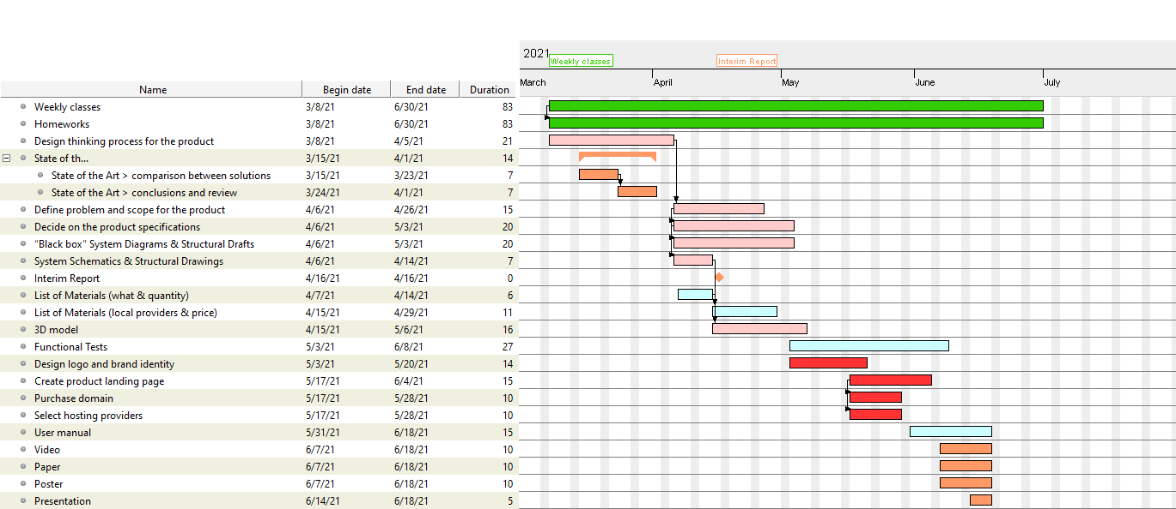
Release Gantt chart
“Black box” System Diagrams
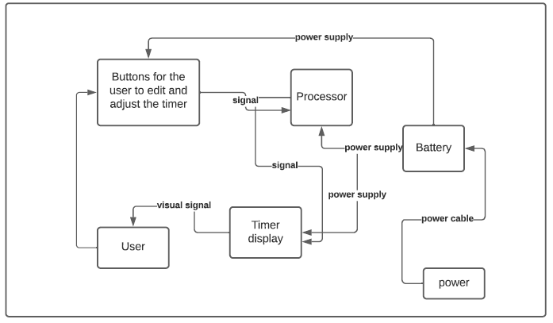
Black box diagram

